9.3.1

Hello Danielle

Hello Sofi. How are you?

I'm good. How are you?

I'm good

What's this?

This is cooking 101. These are a my students. I teach this class

You are a teacher and a cook?

Yes

Cooking 101? Is it the beginner class?

Yes. Next month is cooking 102. The intermediate class

Oh. What is the class about today?

Chicken soup.

Uhm

Can you help me?

Yes. I can

Okay

First. I need my knives...Thank you

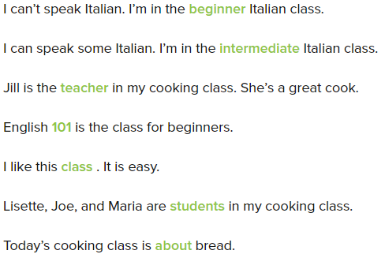

What class is for intermediate students?

Italian Cooking 102.

Who is the teacher for the class at Punjabi Palace Restaurant?

Seema Melani.

What class is for beginners?

Chinese Cooking 101.

Who is the teacher for the Chinese cooking class?

Ellen Fong.

What class is for good cooks?

Indian Cooking 202.

What can you make in Italian Cooking 102?

Pasta and bread.

When is the beginner class?

Monday, 5-7PM

Where is the intermediate class?

Bella Donna Italidan restaurant.

Hello Danielle

Hi there. How are you?

Fine, thanks. So, what’s this class?

This is Cooking 102. These are my student

Is it the beginner class?

No, it’s not. It’s an intermediate

Oh. What’s class about today?

Pizza and salad

Ohh. I like pizza

Hey, can help me now?

Yes. I can

Okay. Please help me with these green peppers

I can do that. Are they for the pizza?

Yes, they are. Thank you!

Timo can’t speak English. He needs to take English 101

Kim is a student in a drawing class. She’s not good at drawing, but she like it

I can cook a little, but I’m not a good cook. I need an intermediate cooking class

We’re in Mr.Chen’s Chinese class. He’s a good teacher

Henry is a beginner. He can take Cooking 101

9.3.2

Okay, students. Listen please. Where are you knife? Good. Now dice the vegetables

I don’t understand. Can you repeat that, please?

Dice the vegetables

What does “dice” mean?

Dice mean to cut into small pieces with your knife. Okay, Pay attention! Now we cook the vegatables. Sofi, can you help my students?

Okay

The students need knives for this class

Sofi and the students dice the vegetables first

How do you make chicken soup

* First, you cook vegetables

Sofi helps the students. Why?

* She can dice, and they can’t

Excuse me. How much is teh flashlight?

I’m sorry.. I don’t understand

I can’t speak English well

Can you repeat that, please?

Okay, How much is the flashlight?

What does "flashlight" mean?

"Flashlight" is a thing that makes light.

Oh, I understand now! ... It’s five dollars.

Okay. Thank you.

Okay students. Pay attention

Okay, Danielle

Do you have your knife?

Yes, I do

Where is your chicken?

Here is it

Good. Now dice the chicken?

I don’t understand. Can you repeat that. Please?

Dice the chicken

What does dice mean?

Dice mean to cut into small pieces with your knife

Oh, okay. I understand now

Good. Now listen please. Cook the chicken

Excuse me. I need help

Do you need help?

Yes. I can’t dice my chicken

Okay. I can help you

Thanks, Danielle

Excuse me, where is Barkley’s Restaurant?

What does “chop” mean?

“Chop” means to cut into big pieces with your knife

Can you repeat that, please?

Students, pay attention, please!

I’m sorry, I don’t undersatand

Cook the vegetables now

Can you help me, please?

**9.3.3**

Excuse me, do you need some help?

Yes. I do. I need some help, please. It's difficult

No. It's easy. I can teach you

Okay, students. It's good, but it's not great. What does the soup need? Yes

It needs some salt

That's right

Thank you

You're welcome

Okay. It's 11 o'clock. It's time to go. Take some soup, It's yours!

Thank you for a class today, Danielle.

You're welcome

How is the weather today?

It’s hot and sunny.

What time is it?

It’s four o’clock.

When is your birthday?

It’s today.

What does the soup need?

It needs vegetables.

How is your cooking class?

It’s difficult.

What time does the restaurant open?

It opens at five o’clock.

How is the cake?

It’s good, but it’s not great.

Is this Greg’s cell phone?

No. It’s yours!

Is the cooking class easy for the student?

No, It’s difficult.

What’s easy for Sofi?

Cooking.

What’s good?

The soup

What happens at eleven o’clock?

The student go home.

Is the soup for the restaurant?

Yes, It isn’t. It’s for the students.

Do you need some help?

Yes. I need some help, please.

What can I do?

I can't dice this chicken. It's difficult.

No, It's easy. I can teach you.

OK, Thank you.

Do you want some soup?

Yes, please. Hmmm. It's good. but It's not great.

What does it need?

It needs more vegetables.

That's right , And It needs salt.

OK, I have vegetables and salt, Here you are.

Good. Oh. It's 9 o'clock.

Oh. it's time to go

Yes. take some soup.

It's for me ? Thank you . And thank you for the class today.

It’s sunny

It’s cold

It’s easy

It’s difficult.

It’s eight o’clock.

It’s my birthday.

It’s Monday.

It’s delecious.

It needs salt.

My class is Cooking 101.

There are ten students in the class.

Can you repeat that, please?

Can you spell that, please?

My English class is easy.

It’s time to go.

It’s easy. I can teach you.

Do you need some help?

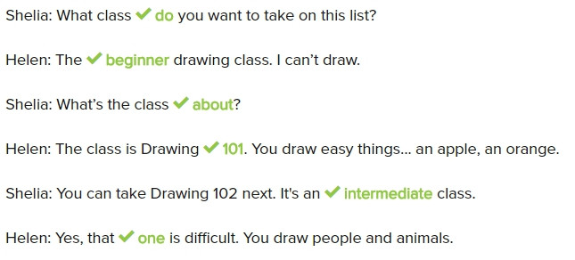

R: Is this class difficult?

S: No, It’s easy. It’s a beginner class.

Ann: Is that computer class difficult?

S: Yes, that’s Computer 302.

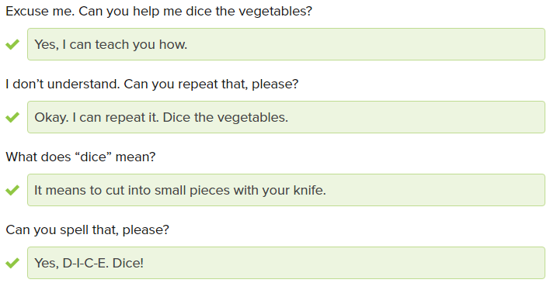

What’s this vegetable ?

It’s a green pepper.

Do you need some help?

Yes, I do. I don’t understand.

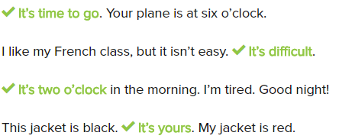

Do you like the soup?

Yes, it’s good.

Excuse me. Do you need some help?

Yes, I do. It’s difficult.

No, it’s easy. I can teach you.

Thank you.

You’re welcome

Excuse me. Do you need some help?

No, Thank you. I can do it.